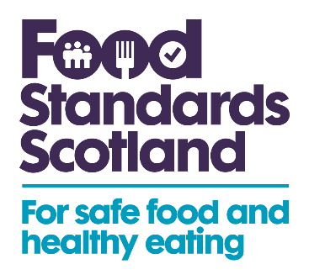

**Christmas Campaign: Social Media Copy**

**The following is suggested copy to include across your social channels alongside the social media images provided.**

*This Christmas, no one wants to end up with food poisoning.* [*@FSScot*](https://twitter.com/FSScot) *have made a checklist to help remind you of some easy food safety practices for this time of year. Find out more:* [*https://bit.ly/3I4Ahk9*](https://bit.ly/3I4Ahk9)

*Learn more about the importance of storing and preparing food safely during the Christmas period – and find some simple food safety practices – on this* [*@FSScot*](https://twitter.com/FSScot) *checklist:* [*https://bit.ly/3I4Ahk9*](https://bit.ly/3I4Ahk9)

*Christmas can be a magical time of year, but not if you end up with food poisoning! Food Standard Scotland created a checklist of some easy food safety practices to help you reduce this risk. Find out more:* [*https://bit.ly/3I4Ahk9*](https://bit.ly/3I4Ahk9)